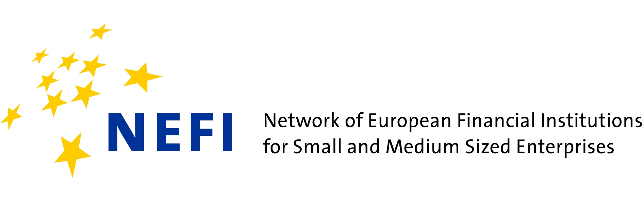

NETWORK COORDINATOR
Network of European Financial Institutions for SMEs (NEFI)
Brussels, Belgium
(part time)

NEFI, a network of leading European National Financial Development Promotional Institutions, is recruiting a motivated Coordinator to lead its Brussels-based Secretariat. The NEFI Coordinator works in close cooperation with the NEFI members.

RESPONSIBILITIES

The Coordinator will be responsible for:
- Daily monitoring and research on topics interesting to NEFI;
- Communication of relevant information to NEFI members;
- Preparation and coordination of papers and other relevant materials for the communication with EU institutions;
- Attending workshops and other meetings on behalf of NEFI and reporting to NEFI members thereafter;
- On specific occasions, speaking at events or meetings on behalf of individual NEFI members or on behalf of NEFI in accordance with the NEFI members;
- Preparation, attending and follow-up of NEFI meetings, workshops and projects, in cooperation with the host of the meeting (currently up to five meetings p.a. in different Member States);
- Updating the NEFI homepage (typo 3), intranet and brochure;

PROFILE - SKILLS AND QUALIFICATION

- Bachelor or Master or comparable degree, background in Finance, Business and/or Economics is desirable;
- Professional experience on a junior level in banking/capital markets or work experience on a junior level in banking sector is a plus;
- Knowledge of EU Institutions and EU financial instruments would be highly appreciated;
- Fluency in written and spoken English. Active knowledge of other European languages would be advantageous;
- Computer skills: excellent working knowledge of Microsoft Office; excellent internet research skills, typo3;
- Personal skills: Highly organised and able to pay close attention to detail; able to work individually but also as a team player; highly motivated and communicative;
- Willingness to travel in Europe;
- Flexibility in working hours is desirable.

BACKGROUND INFORMATION

The Network of European Financial Institutions for SMEs (NEFI) is a network of leading European National Promotional Financial Institutions. It was founded in 1999 and today consists of 18 financial institutions from 18 member states of the European Union:
ALMI (Sweden), ALTUM (Latvia), AWS (Austria), British Business Bank (United Kingdom), BGK(Poland), BDB (Bulgaria), Bpifrance (France), CMZRB (Czechia), Finnvera (Finland), HBOR (Croatia), ICO(Spain), KfWGroup (Germany), Kredex (Estonia), MFB (Hungary), SBCI (Ireland), SID Bank (Slovenia),SNCI (Luxembourg) and SZRB (Slovakia).

These institutions share a public mission to facilitate access to finance for small and medium-sized enterprises (SMEs). NEFI partners act complementarily to and in cooperation with the national banking system by providing co-financing, risk-sharing arrangements, expertise and advice in order to address shortcomings in the SME financial markets. For more information see www.nefi.eu.

THE NETWORK OFFERS

- Work in Brussels;
- Competitive salary under Belgian law;
- Duration of contract: 2 years with possibility of prolongation
- Starting date: As soon as possible.

Vacancies are open until 6 March 2019. Please send your CV and motivation letter to info@sbra.be.
While the Network of European Financial Institutions for SMEs (NEFI) is registered in the EU transparency registry, it is not a legal entity but an informal network of 18 financial institutions. Therefore the NEFI Coordinator will sign an employment contract under Belgian law at the Slovenian Business & Research Association (SBRA - www.sbra.be/en/NEFI), Brussel’s based NGO which acts as the host institution for the network.

